# **TITLE OF PAPER IN ENGLISH**

## **First Author1, Second Author2, Third Author3**

### *1First Institution (Company), Country Name; 2Second Institution (Company), Country Name; 3Third Institution (Company), Country Name*

**Abstract**: This document gives formatting instructions for authors preparing papers for publication in the Proceedings of the “Interdisciplinarity as a key link of the project profession” congress. The authors must follow the instructions given in the document in order for the papers to be published. You should use this document as a template into which you can type your own text. The abstract should contain a summary of the paper in 150 to 200 words, providing information about the purpose of the paper, research methods and the most important findings and implications. It should be typed using single spaced paragraph without indentation and in Times New Roman 12 font. Papers and reports should be submitted in Serbian or English language.

**Keywords**: Include 3-6 keywords separated by commas (e.g. responsible project management, responsible project start-ups, circular economy)

**1. INTRODUCTION**

We highly recommend using this document as a template for word processing. For questions on paper guidelines, please contact the congress organization at: [congress@ipma.rs](mailto:congress@ipma.rs).

The paper should contain title, list of authors, institutional affiliations, abstract and keywords.

The paper should be between 1500 and 3000 words in length (including text, figures, tables, references list, and appendix). The full paper should be submitted to the organizer in electronic form by e-mail: [congress@ipma.rs](mailto:congress@ipma.rs).

**1.1. CITATIONS IN THE TEXT**

Please ensure that every reference cited in the text is also present in the reference list (and vice versa).

Please use APA (American Psychological Association) in-text and reference list citations. Put the citation(s) in parentheses, use author's last name followed by the year of publication (Rogers, 2019). In the case of two authors, indicate both authors' names and the year of publication as following (Schwaber & Sutherland, 2017). For references with three or more authors include only the surname of the first author followed by "et al." and the year of publication such as (Asquin et al., 2010; Brucker et al., 1999). If the authors have more than one publication in a year, use the following notation (Berić et al., 2020a, 2020b).

When the name of the author or the date appear as part of the narrative, cite only missing information in parentheses. For example Highsmith (2009) concluded that… Schwaber and Sutherland (2017) suggested that… Berić et al. (2020a) found…

**1.2. PAGE LAYOUT**

Paged size of the manuscript should be A4, with a width of 210 mm (8.27") and a length of 297 mm (11.69"). Margins should be set as follows:

* Top = 25 mm
* Bottom = 25 mm
* Left = 25 mm
* Right = 25 mm

The title of a paper should be typed using uppercase bold letters, Times New Roman 14pt font in continuation (without any line breaks). Below it, in Times New Roman, bold, 12pt, centred, put the names of authors, their institutions, addresses of institutions including the country name, as shown in this document. If all authors are from the same country, include the country name only once at the end of the affiliation. Leave two blank lines after the institutional affiliation list.

All body text should be fully justified. Paragraphs should be single-spaced without first-line indentation and with one line gap between consecutive paragraphs. There should be two line gaps between paragraph and next first-level heading. There should not be any styles applied to any of the text in the paper, other than Normal style.

There should not be more than three levels of headings (**1.** / 1.1. / 1.1.1.). The following headings and subheading format should be used:

**1. FIRST LEVEL (Times New Roman, bold, size 13pt, uppercase)**

**1.1. SECOND LEVEL (Times New Roman, bold, size 12pt, uppercase)**

**1.1.1. Third level (Times New Roman, bold, size 12pt, sentence case, except for proper nouns or acronyms)**

Equations should be centred, in line with text, with the number indicators to the right, as shown:

(1)



Figures should be presented in JPG or TIFF file formats while making sure that they are centred, in line with text and within the margins. Below each figure caption and reference for the figure should be presented. If the figure is the original work of authors, the reference is not required.

[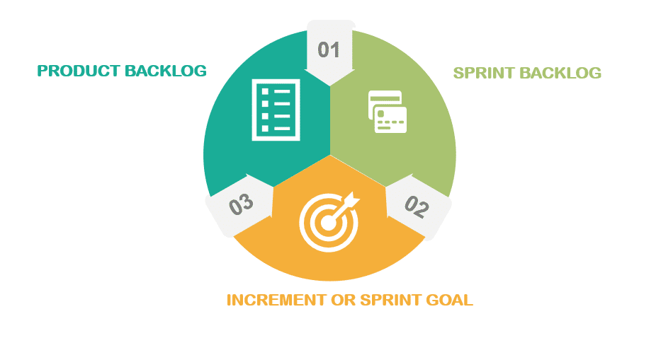](http://www.freedigitalphotos.net/images/Television_Video_and_g178-TV_p11679.html)

**Figure 1.** Figure caption (Highsmith, 2009)

Tables should be within the margins and presented in the following way:

**Table 1.** Table name (Lester, 2017)

| **Research Elements** | **Percent of Team Members** | **Percent of Executives** |
| --- | --- | --- |
| *Application of Project Planning Methods* | 67 | 80 |
| *Application of Project Control Methods* | 60 | 75 |

**REFERENCES**

Reference list should be at the end of the paper and not presented in the footnotes or endnotes. They should be formatted as follows:

For journal articles:

Asquin, A., Garel, G., & Picq., T. (2010). When project-based management causess distress at work. International Journal of Project Management, 28(2), 166-172.

Brucker, P., Drexl, A., Mohring, R., Neumann, K., & Pesch, E. (1999). Resource-constrained project scheduling: notation, classification, models and methods. European Journal of Operational Research, 112(1), 3-41.

Berić, I., Ostojić, B., Pavlović, K., & Pećić, M. (2020a). Management education and sustainable development projects. European Project Management Journal, 10(1), 69-77.

Berić, I., Jovanović, J., & Mosurović, M. (2020b). Risk as a factor of decision making in projects financing of infrastructure projects. European Project Management Journal, 10(2), 11-17.

Reich, B.H. (in press). Managing knowledge and learning in IT projects: A conceptual framework and guidelines for practice. Project Management Journal, 2007.

Rogers, T. (2019). Project success and project team individuals. European Project Management Journal, 9(1), 27-33.

For books:

Highsmith, J. (2009).Agile Project Management. United States of America: Pearson Education Inc.

Lester, A. (2017).Project Management Planning and Control. United States of America: Butterworth-Heineman.

Schwaber, K., & Sutherland, J. (2017).The Scrum Guide. United States of America: Creative Commons.